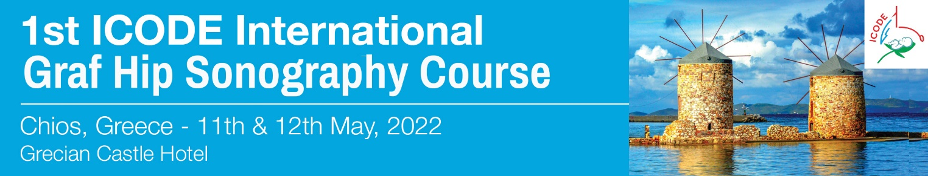

REGISTRATION FORM
please send this form to MikaTravel
For further information regarding the registration please contact: Mrs Eva Gouvianaki - MikaTravel
Email: congress@mikatravel.eu Tel.: + 30 2810223356

Mr /Mrs
Last Name/First Name:
Affiliation:
Tel.: | Mobile:
e-mail:

REGISTRATION FEES

Registration fee (VAT not included): 200€
Includes: Catering & Certificate of Attendance

METHOD OF PAYMENT

By Bank transfer to the order of DIMITRA MYKONIATI – MIKA TRAVEL
(please enclose a copy of the bank transfer. Please state your name and Congress title on the bank transfer)
EUROBANK ERGASIAS
IBAN:GR4902600200000110201259910
BIC: ERBKGRAAXXX
Account Name : Dimitra Mykoniati (Mika Travel)

If you wish to pay by credit card, please contact us.

